Mathematics Specialist Investigations

Year 12

Topic 1: Complex Numbers

Authors: Rom Cirillo
Margaret Denham
Romaine Saunders
Amy Shaw
Ed Taylor

Editors: Rom Cirillo
Romaine Saunders

For each topic three types of tasks are included:
- Extended investigation – an investigation which could be done in the student’s own time followed by an in-class validation. Solutions are provided where practicable for the preparation activity/investigation. For the in-class validation, there are solutions and marking keys which identify the mathematical behaviours that students may exhibit.
- In-class investigation – an investigation for which no prior preparation is required. Solutions and marking keys are provided.
- Investigative questions – a series of short questions which test the student’s ability to apply their learning, to justify their conclusions, to investigate and to generalise, or to solve problems. Such questions could be included in a response or examination assessment. Solutions and marking key are provided.

Screen shot have been produced using the CASIO ClassPad II emulator or the ti-nspire CAS emulator.

Most graphs and diagrams have been produced using efofex software.

© The investigations and solutions in this publication are for the sole use of staff and students of the purchasing school. It is a breach of copyright to distribute them in whole or part in any form now or in the future to any other school, company or person.

Contents:
MATHEMATICS SPECIALIST: Year 12

3.1 Complex numbers
Task 1: Extended investigation: The Factor and Remainder Theorems
Task 2: In-class investigation: Complex numbers using e^{iθ}
Task 3: Investigative questions

3.2 Functions and sketching graphs
Task 4: Extended investigation: The graphs of rational functions
Task 5: In-class investigation: The absolute value function
Task 6: Investigative questions

3.3 Vectors in three dimensions
Task7: Extended investigation: Systems of equations
Task 8: In-class investigation: Cross product
Task 9: Investigative questions

4.1 Integration and applications of integration
Task10: Extended investigation: The Golden Gate bridge
Task 11: In-class investigation: Which sculpture
Task 12: Investigative questions

4.2 Rates of change and differential equations
Task13: Extended investigation: Time of death
Task 14: In-class investigation: The logistic function
Task 15: Investigative questions

4.3 Statistical inference
Task16: Extended investigation: TBA
Task 17: In-class investigation: TBA
Task 18: Investigative questions

This package only contains the investigations associated with topic 3.1: Complex numbers

If your school has purchased the complete set of 18 investigations, you will be informed when the rest are ready for delivery/download, which will be sometime later in Term 1.

TASK 1

The Factor and Remainder Theorems

Extended investigation

Unit 3

Topic 3.1: Complex numbers

Course-related information

The concepts and skills included in this investigation relate to the following dot points within the WA Mathematics Specialist syllabus.
3.1.13 prove and apply the factor theorem and the remainder theorem for polynomials
3.1.14 consider conjugate roots for polynomials with real coefficients
3.1.15 solve simple polynomial equations

The ability to choose and use appropriate technology to enhance and extend concept development is also incorporated within some of the items.

Background information
Students need to be able to calculate using long division, factorise and solve trinomials, multiply algebraic terms and to be able to use the quadratic formula

Task conditions

Students should complete the preparation activity within a given time period (up to one week). Students may use their CAS calculator to check answers (as instructed) during the preparation activity and should be given access to the solutions to the activity before attempting the validation. The validation task consists of two sections, a calculator free section and a section for which students need access to a CAS calculator. The validation task will test the skills and concepts developed in the preparation activity as well as extend these skills and concepts.

Factor and Remainder Theorems

Extended investigation Preparation activity

- Function Notation.

You may be asked to substitute a value into a function in the following manner.

If , find .

Question 1

If , find

B. Long Division

Example 1:

You are asked to divide 27 by 4. You get the answer 6 and a remainder of 3.
We could write this as:

Another way of thinking of this is:

Example 2: Long division.

In primary school you may have been asked to calculate using Long Division. Consider an example where you are asked to divide 67832 by 17.

We multiply 17 by 3 = 51
67 - 51 = 16. Then bring down the 8

Multiply 17 by 9 = 153
168 - 153 = 15. Then bring down the 3.

Multiply 17 by 9 = 153.
153 – 153 = 0. Then bring down the 2.

We multiply 17 by 0 = 0
2 – 0 = 2. This is the remainder.

So we can conclude , or to put it another way,

Note: 67832 is called the dividend, 17 is called the divisor, 3990 is the quotient and 2 is the remainder.

Question 2

Calculate the following using long division, showing full working out.

- Polynomial Division

Dividing a polynomial by another polynomial is similar to performing a division of numbers using long division. For example, divide the polynomial by

Worked solution
Step 1 first divide into to get

Step 2
now multiply by to get then subtract from to get

Step 3
Bring down the . Divide byto get

Step 4
Multiply by to get . Subtract from to get
Step 5
Bring down the 46
Divide by to get 3.
Multiply by 3 to get .
Subtract from to get 19.
We cannot divide into 19 so this is the remainder.

Therefore divided by is
This can also be written as
In general, when we divide the polynomial by the polynomial we obtain two polynomials, the quotient and the remainder, such that;
.
If has degree one (as in our case above) then the remainder will be a constant (e.g. 19).
Question 3

Perform the following calculations showing full working out.

- Divide by

You may use your CAS calculator to check that you have the correct quotient and remainder

Question 4

Without using a CAS calculator, factorise and solve the following equations. For each part, draw a graph of and note the connection (if any) between the solutions and the graph of

Although you may use your CAS calculator to check that you have the correct solutions, you need to make sure that you are also able to do each of these problems without the aid of a CAS calculator.

End of Preparation Activity
Factor and Remainder Theorems

Extended investigation In-class validation (65 marks)

Section one: Calculator free (37 marks)

Example 1:

Fully factorise given that is a factor of .

Step 1.

Step 2.

When is divided by ,there is no remainder and the factors of are , and .

Question 1 (5 marks)

Fully factorise =, givenis a factor of the polynomial and state in its factor form.

Question 2 (5,5 = 10 marks)

- Fully factorise given that is a factor of .

- 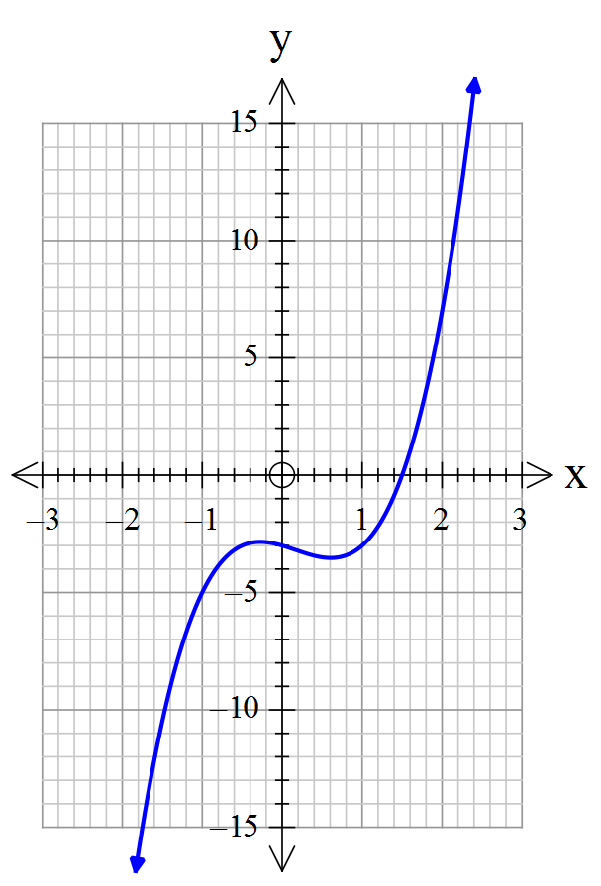Solve =0, and using the graph ofprovided, explain the relationship between the solutions to =0 and the intercepts of .

Question 3 (5,1,1 = 7 marks)

- Complete the table by dividing the polynomial by the given divisor.

Divisor  (x - b) | b | Quotient  P(x) ÷ (x – b) | Remainder | P(b)
 | 3 |  | 30
 | 2
 | -2 |  | -15 | -15
 | 1 |  | 0
 | -3 |  | -60 | -60
 | -1 |  | 2
Working space – if required

- Use the results in the table above, to make a statement about the relationship between the remainder and P(b).

- Complete the following statement:
The remainder of the division of a polynomial P(x) by a linear polynomial (x – b) is equal to ______.

Question 4 (5 marks)
Complete the table for the polynomial
Divisor  (x – b) | b | Remainder  P(b) | Is (x – b) a factor of P(x)?
(x + 1) | -1 | 0 | Yes
(x - 2)
(x - 3)
(x + 3)
(x + 4) | -4 | -18 | No
(x - 5) | 5 | 144
(x + 6) | -6 | -120

Question 5 (1,2,1 = 4 marks)

- When a binomial is a factor of a polynomial, how is the constant term of the binomial related to the constant term of the polynomial? Specifically, how is b related to the – 6 from the polynomial of the table above?

_____________________________________________________________

- Complete the statement below:

(x – b) is a factor of a polynomial P(x) if and only if _____________.

Similarly, (ax – b) is a factor of P(x) if and only if _____________.

- Use the results in the table in Question 4 to complete the following:

If x = b is an integral zero of a polynomial P(x) with integral coefficients, then b is a ___________ of the constant term of the polynomial

Question 6 (2,1,3 = 6 marks)

- State all the possible values of b for the binomial factor, (x – b), of .

- What is the maximum number of factors for this polynomial? _______

- State the three binomial factors of .

Factor and Remainder Theorems

Extended investigation In-class validation (65 marks)

Section Two: Calculator assumed (28 marks)

Question 7 (3, 3, 4, 5, 4, 9 = 28 marks)

- Sketch the graph of on the axes provided below.
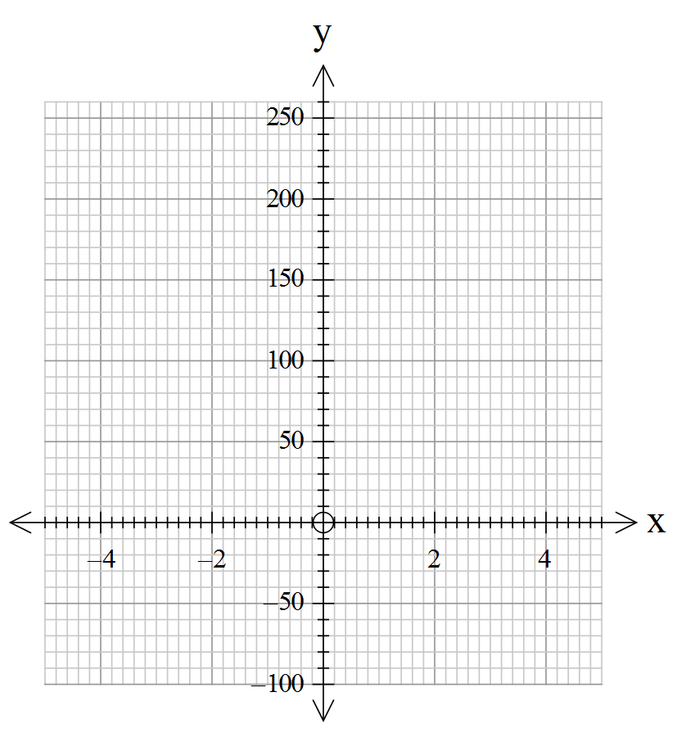

- State the x and y intercepts of the graph.

- Use the graph to state the number of real number roots to
- = 0

- = - 20

- = 72

- Write all the equations from part (c) in factor form (rounding to 1 decimal place, as required)
(i)

(ii)

(iii)

- State all solutions, including complex ones to the equations from part (c)
(i)

(ii)

(iii)

- Write an explanation comparing your results from parts (a), (c) and (d) making reference the relationship between the number and types of roots and factors.

End of questions
Factor and Remainder Theorems

Extended investigation Preparation activity

Solutions

Question 1
Solution

(b)
(c)
(d)
Calculator check:

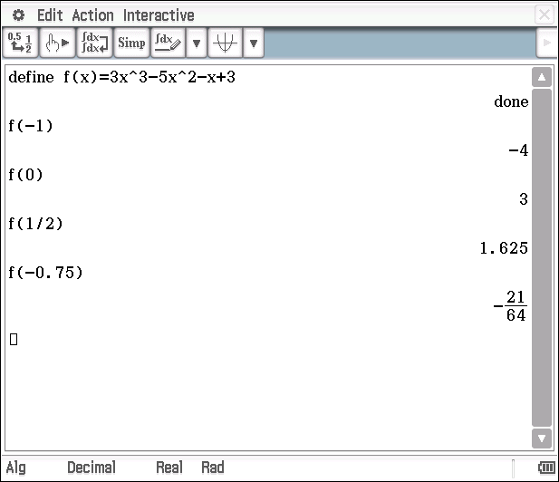

Question 2
Solution
(a) (b)
Calculator check:
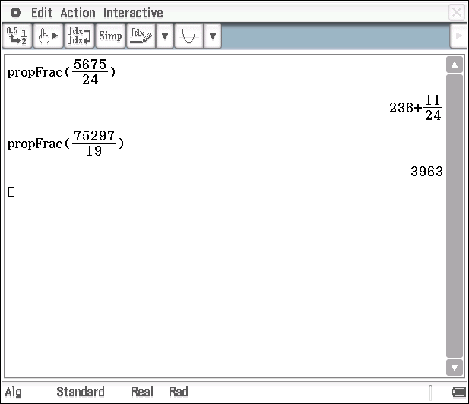

Question 3
Solution
(a)
Note: Although the calculator has ordered the terms differently, the result is equivalent.
Calculator check:
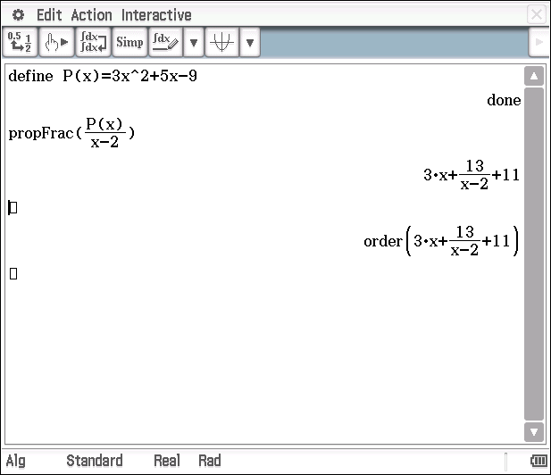
(b)

Calculator check:
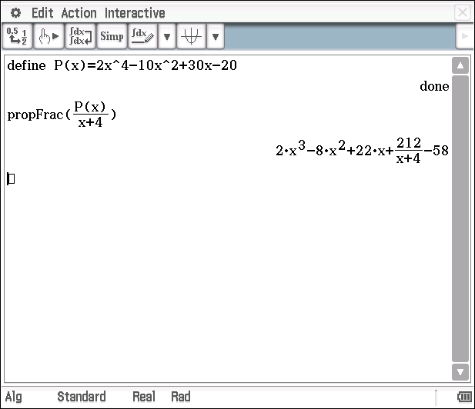

(c)

Calculator check:
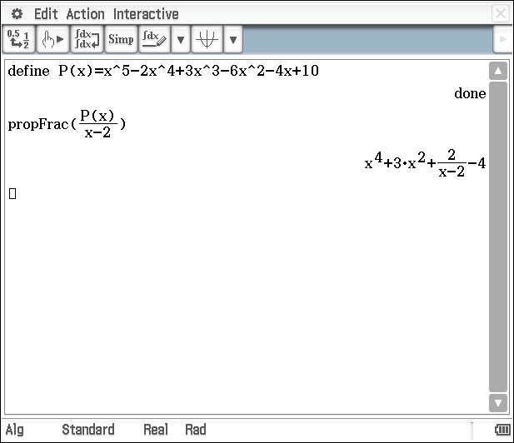
(d)

Calculator check:
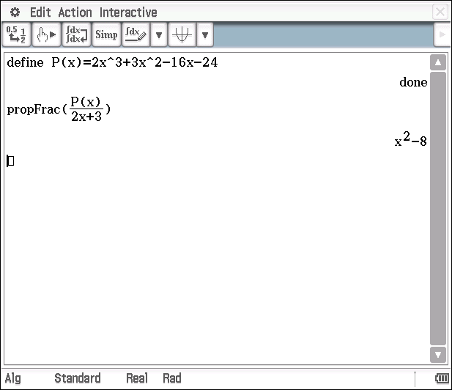

Question 4
Solution
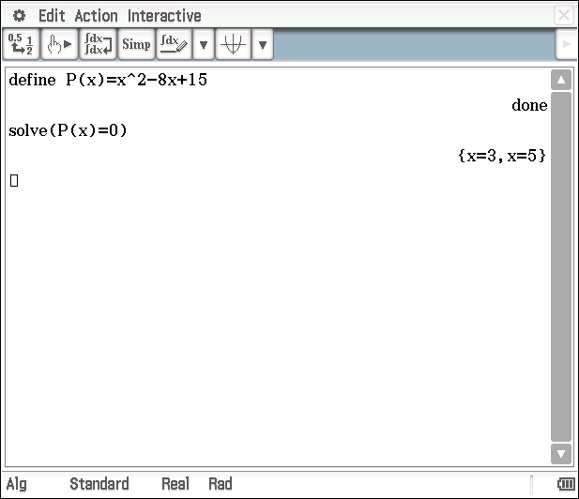
(a)
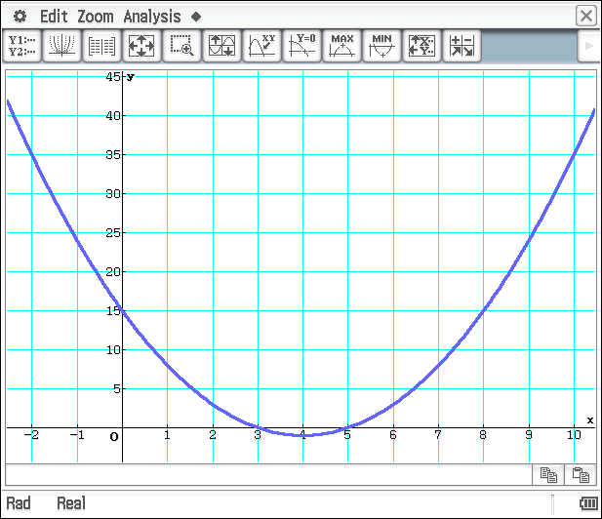
We note that the graph passes through on the x-axis and through y = 15 on the y-axis.

Question 4 (continued)
Solution
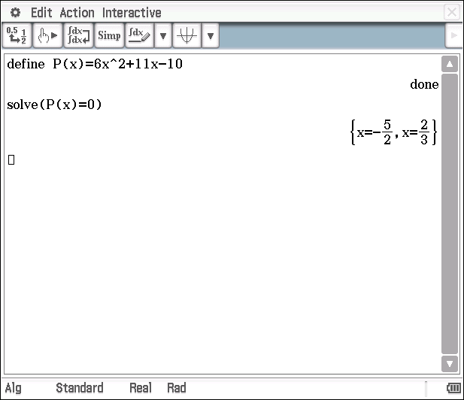
(b)
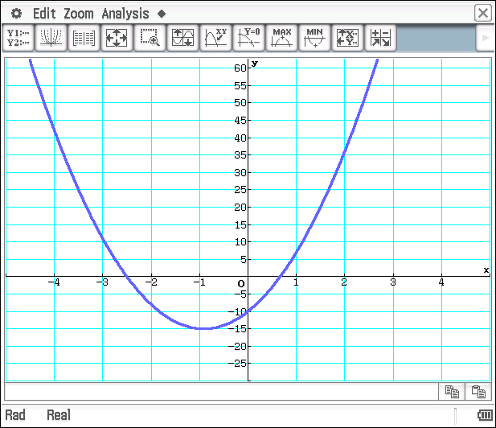
Again, we note that the graph passes through on the x-axis and through y = -10 on the y-axis.

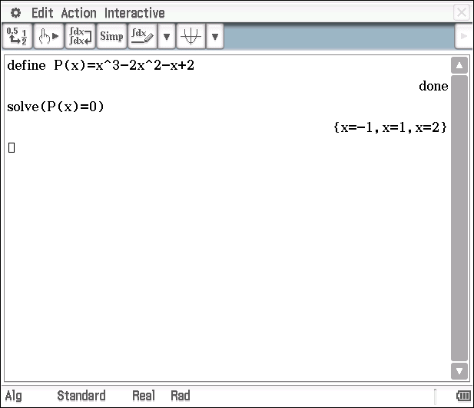
(c)
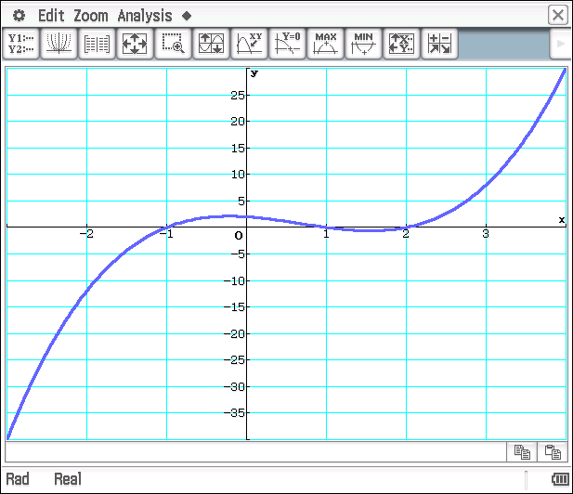

We can see that the graph passes through the three roots on the x-axis and through y = 2 (the constant term in ) on the y-axis.

Question 4 (continued)
Solution
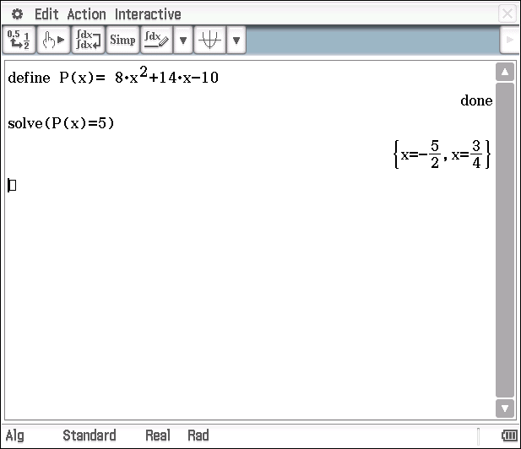
(d)
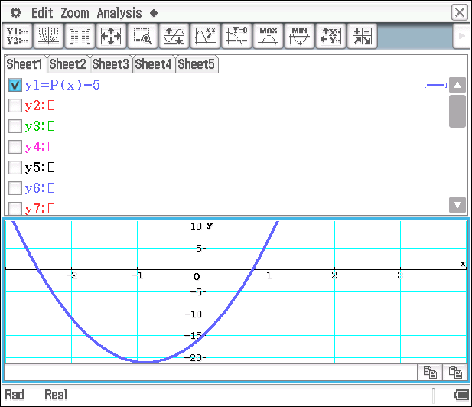

was not able to be factorised into linear factors using rational real numbers. However, - 5 is, as shown by the rational solutions above.
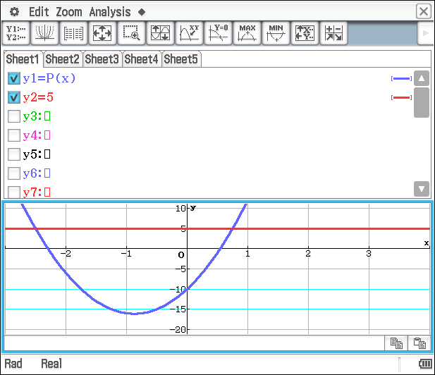
The graph of - 5, passes through on the x-axis and through y = -15 on the y-axis.

Alternatively, this could have been illustrated by the x-intercepts of the points of intersection of y =and y = 5.

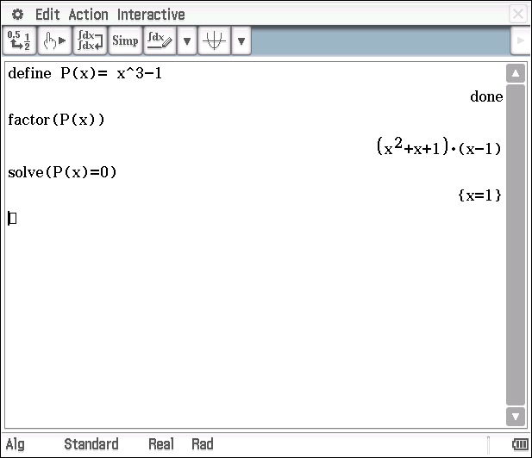
(e)

Note: Real

If we set the CAS calculator in ‘complex’ mode then two additional (complex) solutions are shown.
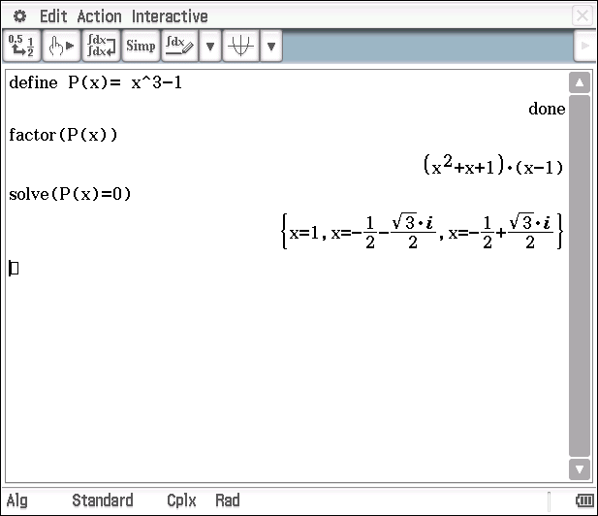

Note: Complex
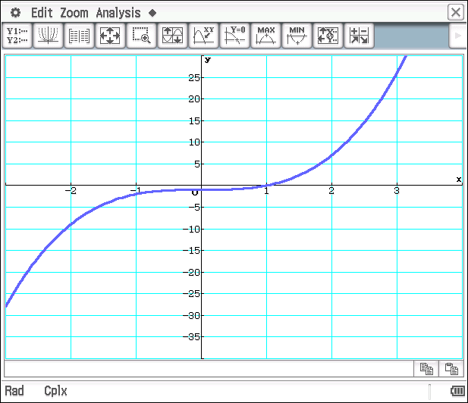

We also note that the graph passes through only one point on the x-axis, (the real root) at and through y = -1 on the y-axis.

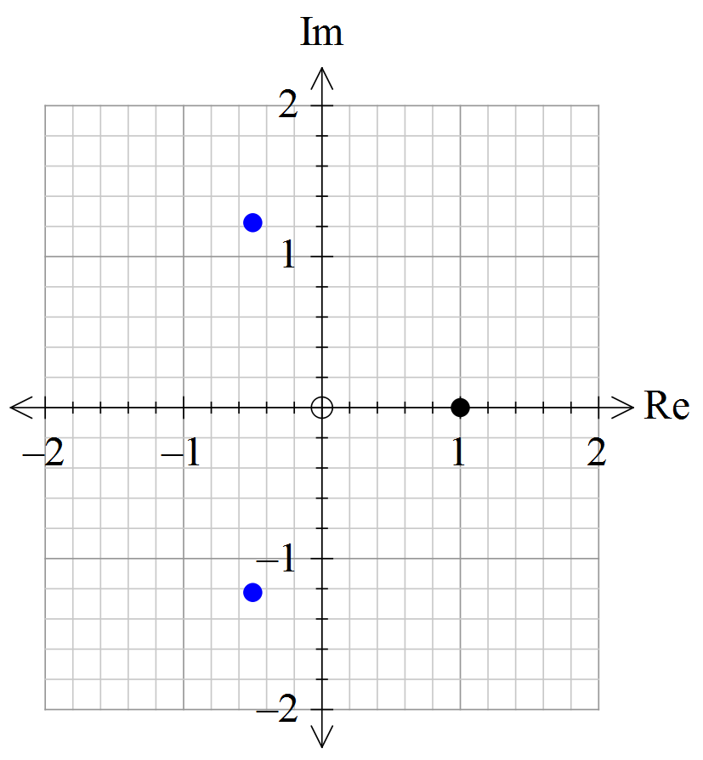

To illustrate the other two roots, that are complex we would need to draw an ARGAND diagram, as shown here.
The real root is plotted at (1,0) and the two complex roots, are plotted at respectively.

You may find it helpful to refer to internet sites relating to the Argand plane – such as the one stated here.
https://www.qub.ac.uk/directorates/media/Media,265159,en.pdf

Factor and Remainder Theorems

Extended investigation In-class validation (65 marks)

Section one: Calculator free (37 marks)

Solutions and marking key

Question 1
Solution
Mathematical behaviours | Marks
- Uses polynomial division correctly  - States three factors of the polynomial | 3  2

Question 2(a)
Solution
Mathematical behaviours | Marks
- Uses polynomial division correctly  - States the two factors of the polynomial, recognising the prime trinomial | 3  1  1
Question 2(b)
Solution
The graph of passes through only one point on the x-axis, which is the only real solution to .
The other two solutions of are complex and cannot be represented on a graph over the real numbers. To represent the two complex roots, an argand diagram is required. It is noted that the two complex roots are complex conjugates of each other.
Mathematical behaviours | Marks
- States as one of the solutions  - Applies the quadratic formula to obtain the other two roots  - States the two complex roots using ‘i’ correctly  - Explains the connection between and the x-intercept of the graph  - Make reference to the complex roots as conjugates or to the need to represent them on an argand diagram | 1  1  1  1  1

Question 3 (a)
Solution
Divisor  (x - b) | b | Quotient  P(x) ÷ (x – b) | Remainder | P(b)
 | 3 |  | 30 | 30
 | 2 |  | 5 | 5
 | -2 |  | -15 | -15
 | 1 |  | 0 | 0
 | -3 |  | -60 | -60
 | -1 |  | 2 | 2

Mathematical behaviours | Marks
- States the correct missing quotient  - States the missing remainder  - States the correct values of P(b) – all correct  - two or three correct | 1  1  2  1
Question 3 (b)
Solution
The remainder and P(b) are the same

Mathematical behaviours | Marks
- Makes the correct statement | 1
Question 3 (c)
Solution
The remainder of the division of a polynomial P(x) by a linear polynomial (x – b) is equal to ___ P(b) ___
Mathematical behaviours | Marks
- Makes the correct statement | 1

Question 4 (a)
Solution
Divisor  (x – b) | b | Remainder  P(b) | Is (x – b) a factor of P(x)?
(x + 1) | -1 | 0 | yes
(x - 2) | 2 | 0 | yes
(x - 3) | 3 | 24 | no
(x + 3) | -3 | 0 | yes
(x + 4) | -4 | -18 | no
(x - 5) | 5 | 144 | no
(x + 6) | -6 | -120 | no

Mathematical behaviours | Marks
- States the correct missing values of b  - States the correct missing values of P(b) (-1/error)  - States correctly, which are factors (-1/error) | 1  2  2

Question 5 (a)
Solution
The constant term of the binomial that is a factor of a polynomial, will be a factor of the constant term of the polynomial.
e.g. b is a factor of -6
Mathematical behaviours | Marks
- Makes the correct statement | 1

Question 5 (b)
Solution
(x – b) is a factor of a polynomial P(x) if and only if P(b) = 0
Similarly, (ax – b) is a factor of P(x) if and only if
Mathematical behaviours | Marks
- Makes the correct statements | 2
Question 5 (c)
Solution
If x = b is an integral zero of a polynomial P(x) with integral coefficients, then b is a ___factor________ of the constant term of the polynomial
Mathematical behaviours | Marks
- Completes the statement correctly | 1

Question 6 (a)
Solution
1, 2, 5, 10, -1, -2, -5, -10
Mathematical behaviours | Marks
- Provides at least 6 of the values  - Provides all values | 1  1

Question 6 (b)
Solution
3
Mathematical behaviours | Marks
- State the correct number | 1

Question 6 (c)
Solution
Mathematical behaviours | Marks
- Uses the factor theorem to test for possible factors  - Determines at least 2 of the factors  - States all three factors correctly | 1  1  1

Factor and Remainder Theorems

Extended investigation In-class validation (65 marks)

Section one: Calculator assumed (28 marks)

Solutions and marking key

Question 7(a)
Solution
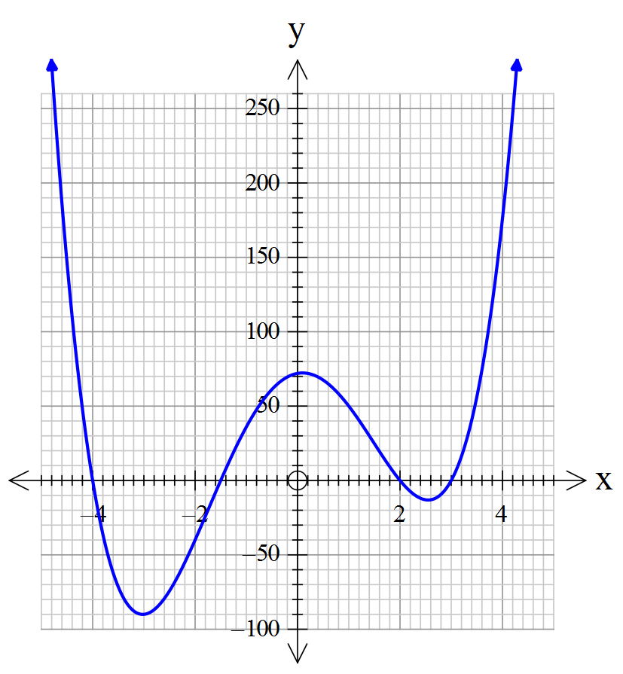
Mathematical behaviours | Marks
- Graph passes through the correct x-intercepts  - Shape and placement of the minimums is approximately correct  - Shape and placement of the maximum is approximately correct | 1  1  1

Question 7(b)
Solution
x-intercepts at x = - 4, -1.5, 2, 3
These may be determined from the calculator by identifying the roots of the graph or by using the factor command in the main menu

y-intercept at (0,72) – obvious from the constant term of the equation or read from the calculator
Mathematical behaviours | Marks
- States the correct y-intercept  - States the correct x-intercepts (-1 for any omissions or errors) | 1  2

Question 7(c)
Solution
- 4

- 2
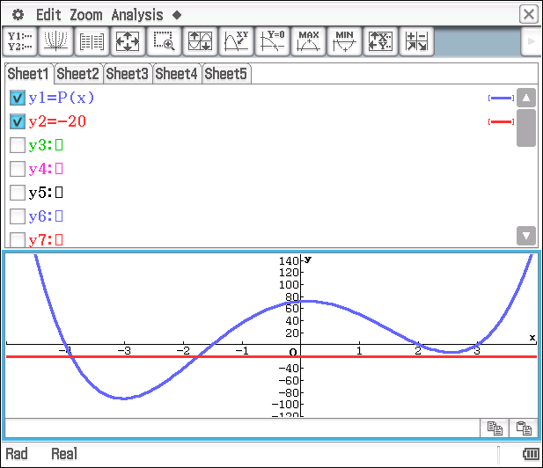

- 4
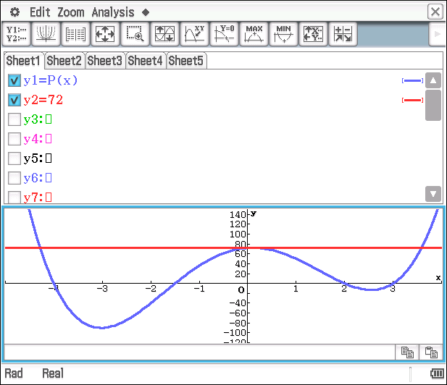

Re-sizing/zooming of the graph around the y-intercept clearly indicates that y=72 crosses the graph of twice near the maximum. Hence 4 roots.
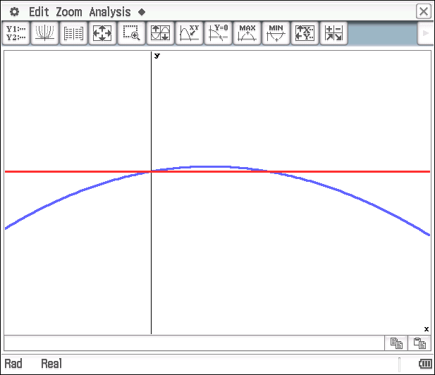
Mathematical behaviours | Marks
- States the correct number of roots  - States the correct number of roots  - States the correct number of roots (1 mark only if gives 3 roots) | 1  1  2

Question 7(d)
Solution
(i)
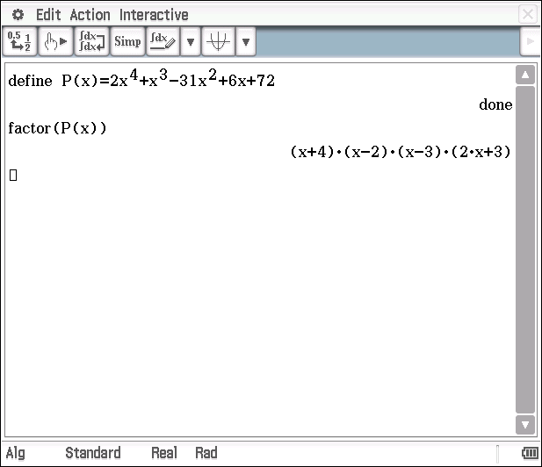

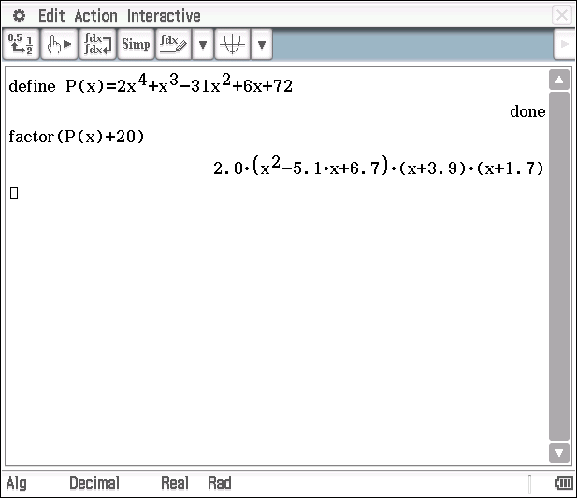
The calculator has been placed in decimal representation and been fixed to 1 decimal place.

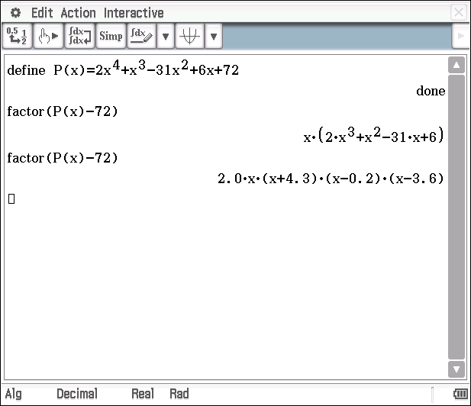

For the second factorising attempt, the calculator has been changed to decimal representation and been fixed to 1 decimal place.
Mathematical behaviours | Marks
- States the equation with correct factors  - States the equation in factor form (to one decimal place)  - States the equation in factor form (to one decimal place) | 1  2  2

Question 7(e)
Solution
(i)
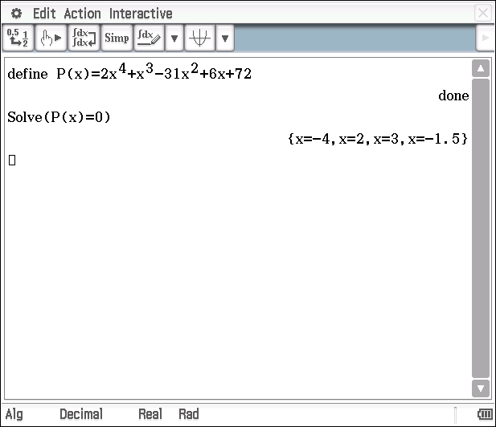

These are the only two real solutions
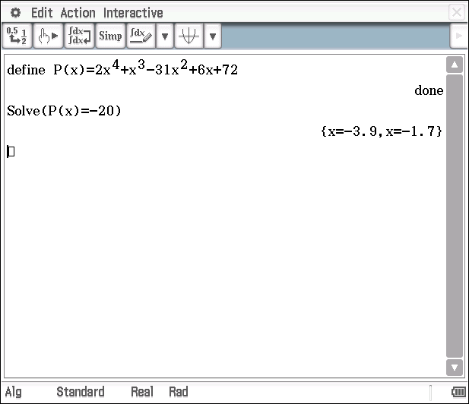

Placing the calculator in complex mode gives the additional two solutions

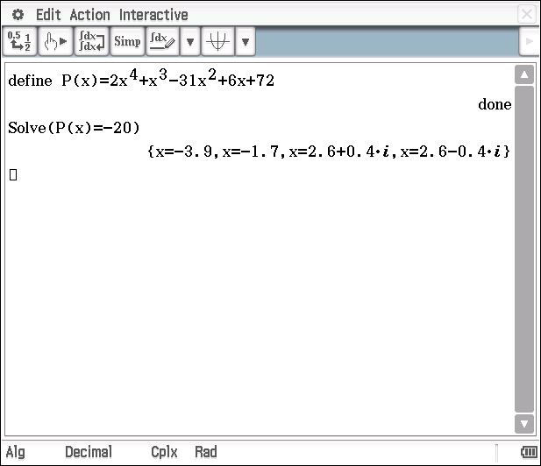

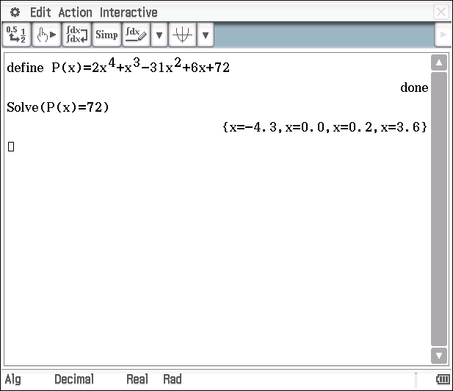

Mathematical behaviours | Marks
- States the four real roots  - States the two real roots (to one decimal place)  States the two complex roots (to one decimal place)  - States the four real roots (to one decimal place) | 1  1  1  1

Question 7(f)
Solution
- The graph of cuts the x-axis at four points so there are four real roots and four linear factors
- The graph of cuts the x-axis at only two points, so there are two linear factors only, two real roots only and two complex roots – which are complex conjugates of each other.
- The are 4 linear factors and 4 real roots as the line y= 72 cuts the graph of at 4 points. (see part (c))
Mathematical behaviours | Marks
- Makes reference to the graph, the roots and the linear factors – all being real  - Links the graph, to the two real roots, noting the linear factors  Notes that the other two roots are complex, and are complex conjugates  - Makes reference to the graph, the roots and the linear factors – all being real, although may be irrational | 3  2  2  2

TASK 2

COMPLEX NUMBERS USING e^{iθ}

In-class investigation

Unit 3

Topic 3.1: Complex numbers

Course-related information

The concepts and skills included in this investigation relate to the following dot points within the WA Mathematics Specialist syllabus.
3.1.1 review real and imaginary parts Re() and Im() of a complex number
3.1.2 review Cartesian form
3.1.3 review complex arithmetic using Cartesian form
3.1.4 use the modulus of a complex number and the argument of a non-zero complex number and prove basic identities involving modulus and argument

Background information

It is assumed that students have completed Methods 1.2.7 – 1.2.8. 1.2.14, 1.2.16 (Trigonometric functions), Specialist 2.1.1, 2.1.3 (The basic trigonometric functions), Specialist 2.3.7 – 2.3.10 (Complex numbers), Specialist 3.1.1 – 3.1.3 (Cartesian forms) and Specialist 3.1.4.

Task conditions

For this task the use of the calculator is not permitted.

Complex numbers using e^{iθ}

In-class investigation (Total marks: 41)

Question 1 (13 marks)

Given

(a) show that
(i) , (4)

(ii) . (2)

Hence,
(b) determine expressions for and for in terms of ,
(3)

(c) solve
(i) , (2)

(ii) . (2)

Question 2 (11 marks)

Given is the exponential form of the complex number , where and ,
(a) express in exponential form, (2)

(b) express in exponential form, (2)

(c) express in Cartesian form. (2)

(d) Hence, express in Cartesian form. (5)

Question 3 (17 marks)

The hyperbolic trigonometric functions and are defined by

(a) Show that
(i) (2)

(ii) (1)

(iii) . (2)

(b) Express in terms of and . (3)

(c) Show that and determine an expression for in terms of .
(3)

(d) Write and in terms of the hyperbolic functions. (3)

(e) Express in Cartesian form. (3)

End of questions

Complex numbers using e^{iθ}

In-class investigation
Solutions and marking key

Question 1(a)(i)
Solution
Mathematical behaviours | Marks
- Correctly substitutes for  - Simplifies the terms  - Identifies the expansion for  - identifies the expansion for | 1  1  1  1

Question 1(a)(ii)
Solution
Replace with ,
Mathematical behaviours | Marks
- Correctly substitutes for  - Simplifies the terms | 1  1

Question 1(b)
Solution
Given that and
Mathematical behaviours | Marks
- Recognises the need for addition to obtain  - Recognises the need for subtraction to obtain  - Correct expressions for and for | 1  1  1
Question 1(c)(i)
Solution
Mathematical behaviours | Marks
- Rewrites the equation in terms of  - Solves for | 1  1

Question 1(c)(i)
Solution
Mathematical behaviours | Marks
- Rewrites the equation in terms of  - Solves for | 1  1

Question 2(a)
Solution
Mathematical behaviours | Marks
- Correct modulus  - Correct argument | 1  1

Question 2(b)
Solution
Mathematical behaviours | Marks
- Correct modulus  - Correct argument | 1  1

Question 2(c)
Solution
Mathematical behaviours | Marks
- Applies definition of  - Expresses in Cartesian form | 1  1

Question 2(d)
Solution
Mathematical behaviours | Marks
- Expresses in exponential form  - Expresses in exponential form  - Applies definition of  - Correct real component  - Correct imaginary component | 1  1  1  1  1

Question 3(a)(i)
Solution
Mathematical behaviours | Marks
- Substitutes for  - Establishes | 1  1

Question 3(a)(ii)
Solution
Mathematical behaviours | Marks
- Establishes | 1

Question 3(a)(iii)
Solution
Mathematical behaviours | Marks
- Substitutes for and  - Simplifies resulting expression | 1  1

Question 3(b)
Solution
Mathematical behaviours | Marks
- Writes expression for  - Factorises numerator  - Rewrites in terms of and | 1  1  1

Question 3(c)
Solution
Mathematical behaviours | Marks
- Substitutes for  - Recognises  - Establishes | 1  1  1

Question 3(d)
Solution
Mathematical behaviours | Marks
- Substitutes for  - Establishes  - Establishes | 1  1  1

Question 3(e)
Solution
Mathematical behaviours | Marks
- Substitutes for  - Applies trig identity  - Simplifies to establish | 1  1  1

TASK 3

INVESTIGATIVE QUESTIONS

Unit 3

Topic 3.1: Complex numbers

Course-related information

The concepts and skills included in these investigative questions relate to the following dot points within the WA Mathematics Specialist syllabus:
3.1.10 identify subsets of the complex plane determined by relations such as
3.1.13 prove and apply the factor theorem and the remainder theorem for polynomials
3.1.15 solve simple polynomial equations

The ability to choose and use appropriate technology to enhance and extend concept development is also incorporated within some of the items.

Background information

It is assumed that students are familiar with Mathematics Methods 1.2.8 (Trigonometric functions), Mathematics Specialist 3.1.4 – 3.1.5 (Complex arithmetic using polar form). Each of the questions provided is stand-alone and may be incorporated into different tasks: it is not intended that they form part of the same assessment task.

Task conditions

These questions are independent of each other and are written so that they may be incorporated into a test or examination Student access to a graphical/CAS calculator is assumed. The time required to complete each question is left to the discretion of the teacher but the intention is that each question may be completed within 15 minutes.
Investigative questions for Topic 3.1

Question 1 (15 marks)

(a) Complete the following table for the cubic equation . (6)

Roots

(b) Write each of the cubic equations in (a) in the form . (3)

(c) Hence, for the cubic equation , express in terms of the roots of the equation . (3)

Consider the cubic equation with roots such that and .

(d) Show that at least one of these roots must be 1. (3)

Question 2 (12 marks)

The Fibonacci polynomials can be defined as
(a) Write down the first seven Fibonacci polynomials . (5)

(b) What is the degree of ? (1)

(c) Simplify
(i) ,

(ii) .

Hence, express in terms of a Fibonacci polynomial. (3)
(d) It is conjectured that , where is a natural number.
Demonstrate that this is true for . (2)

(e) Assuming that is true, what can you conclude about the roots of and the roots of ? (1)

Question 3 (12 marks)
Determine the minimum and maximum values of for each of the following:
(a) (5)
(b) (2)
(c) (5)
Investigative questions for Topic 3.1
Solutions and marking key

Question 1(a)
Solution
 | Roots
 | 1, -2, -3 | 6 | -4 | 1
 | -4, 3, -2 | 24 | -3 | -10
 | -1, -3, -5 | -15 | -9 | 23

Mathematical behaviours | Marks
- Correctly identifies the roots  - Correctly calculates the product of the roots  - Correctly calculates the sum of the roots  - Correctly calculates the sum of products of the roots | 1  1  1  3

Question 1(b)
Solution
Mathematical behaviours | Marks
- Correctly expands  - Correctly expands  - Correctly expands | 1  1  1

Question 1(c)
Solution
Mathematical behaviours | Marks
- Correct expression for  - Correct expression for  - Correct expression for | 1  1  1

Question 1(d)
Solution

Hence, the cubic equation is .
Let , is a root of .
Mathematical behaviours | Marks
- Rewrites the equation in terms of  - Establishes that  - Concludes that is a root of the cubic equation | 1  1  1

Question 2(a)
Solution
Mathematical behaviours | Marks
- Correct expressions for  - Correct expression for  - Correct expression for  - Correct expression for  - Correct expression for | 1  1  1  1  1

Question 2(b)
Solution
is of degree
Mathematical behaviours | Marks
- Correct degree | 1

Question 2(c)
Solution
(i)

(ii)

Mathematical behaviours | Marks
- Simplifies  - Simplifies  - Recognises | 1  1  1

Question 2(d)
Solution
Mathematical behaviours | Marks
- Substitutes  - Demonstrates true for | 1  1

Question 2(e)
Solution
If , then the roots of are also roots of .
Mathematical behaviours | Marks
- Correct conclusion | 1

Question 3(a)
Solution
represents a circle, centre , radius 1
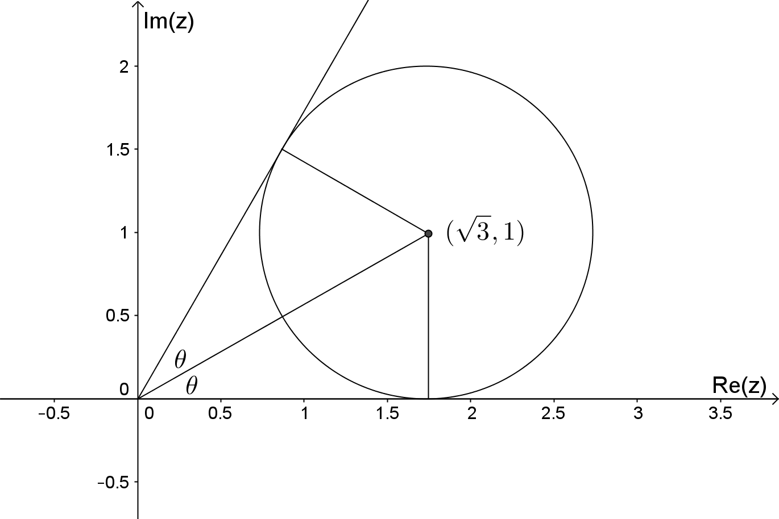

Mathematical behaviours | Marks
- Recognises set of points is a circle  - Correct centre  - Correct radius  - Calculates  - Correct minimum and maximum values for | 1  1  1  1  1

Question 3(b)
Solution
Mathematical behaviours | Marks
- Recognises set of points is a rectangle  - Correct minimum and maximum values for | 1  1

Question 3(c)
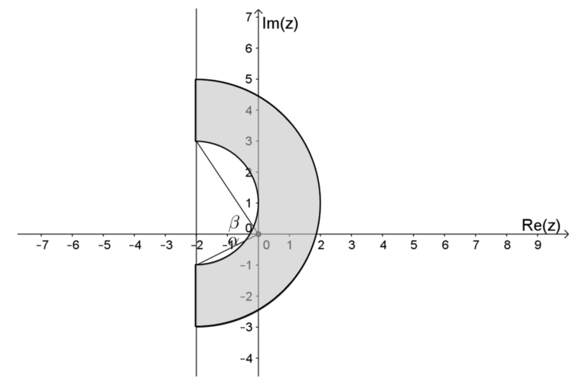

Equation of inner semi-circle is
Mathematical behaviours | Marks
- Recognises equation of inner circle is required  - Determines Cartesian equation of circle  - Determines coordinates of end points  - Correct minimum value for  - Correct maximum value for | 1  1  1  1  1

